

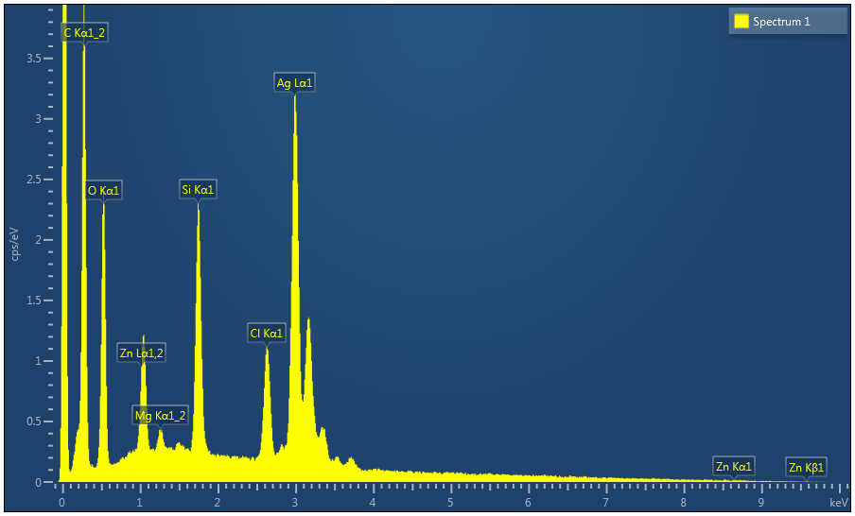

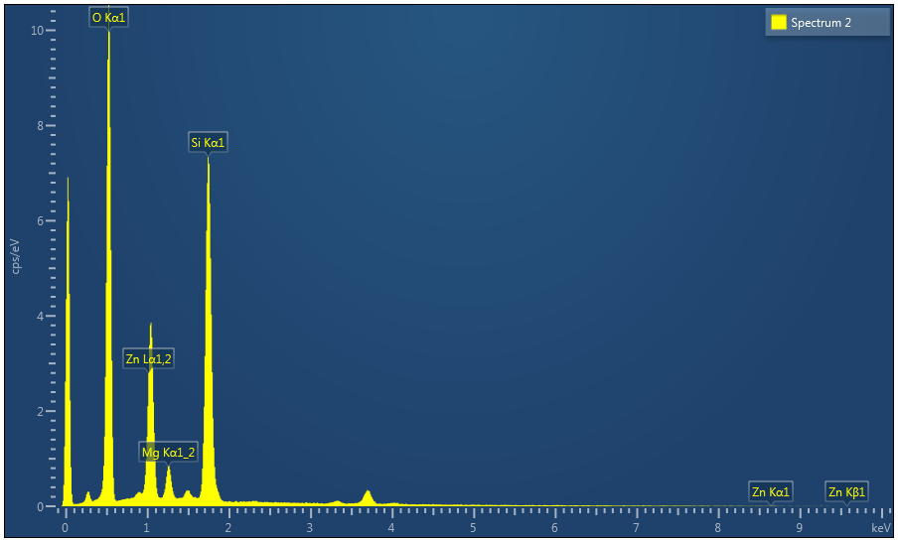

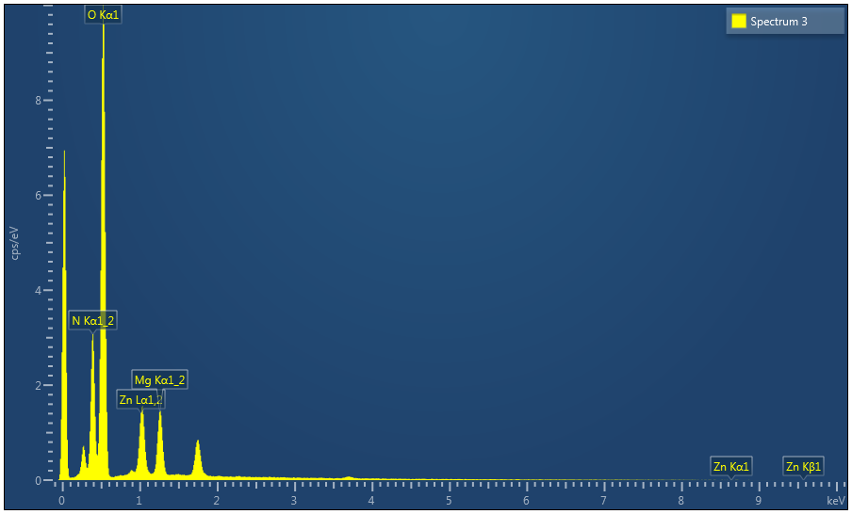

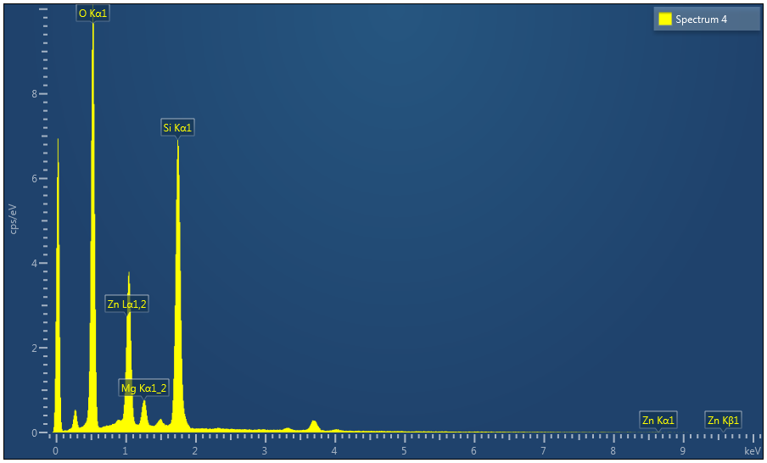

|  |  |
| --- | --- |
| Result Type | Atomic % |

|  |  |  |  |  |
| --- | --- | --- | --- | --- |
| Spectrum Label | Spectrum 1 | Spectrum 2 | Spectrum 3 | Spectrum 4 |
| C | 43.27 |  |  |  |
| N |  |  | 29.08 |  |
| O | 28.55 | 64.11 | 62.93 | 64.40 |
| Mg | 0.66 | 2.90 | 4.79 | 2.82 |
| Si | 6.78 | 26.48 |  | 26.15 |
| Cl | 3.66 |  |  |  |
| Zn | 1.98 | 6.51 | 3.20 | 6.63 |
| Ag | 15.11 |  |  |  |
| Total | 100.00 | 100.00 | 100.00 | 100.00 |

|  |  |  |  |  |  |  |  |  |
| --- | --- | --- | --- | --- | --- | --- | --- | --- |
| Statistics | C | N | O | Mg | Si | Cl | Zn | Ag |
| Max | 43.27 | 29.08 | 64.40 | 4.79 | 26.48 | 3.66 | 6.63 | 15.11 |
| Min | 43.27 | 29.08 | 28.55 | 0.66 | 6.78 | 3.66 | 1.98 | 15.11 |
| Average |  |  | 55.00 | 2.79 |  |  | 4.58 |  |
| Standard Deviation |  |  | 17.64 | 1.69 |  |  | 2.35 |  |